TEAM PDQ
Final Report
2011-2012
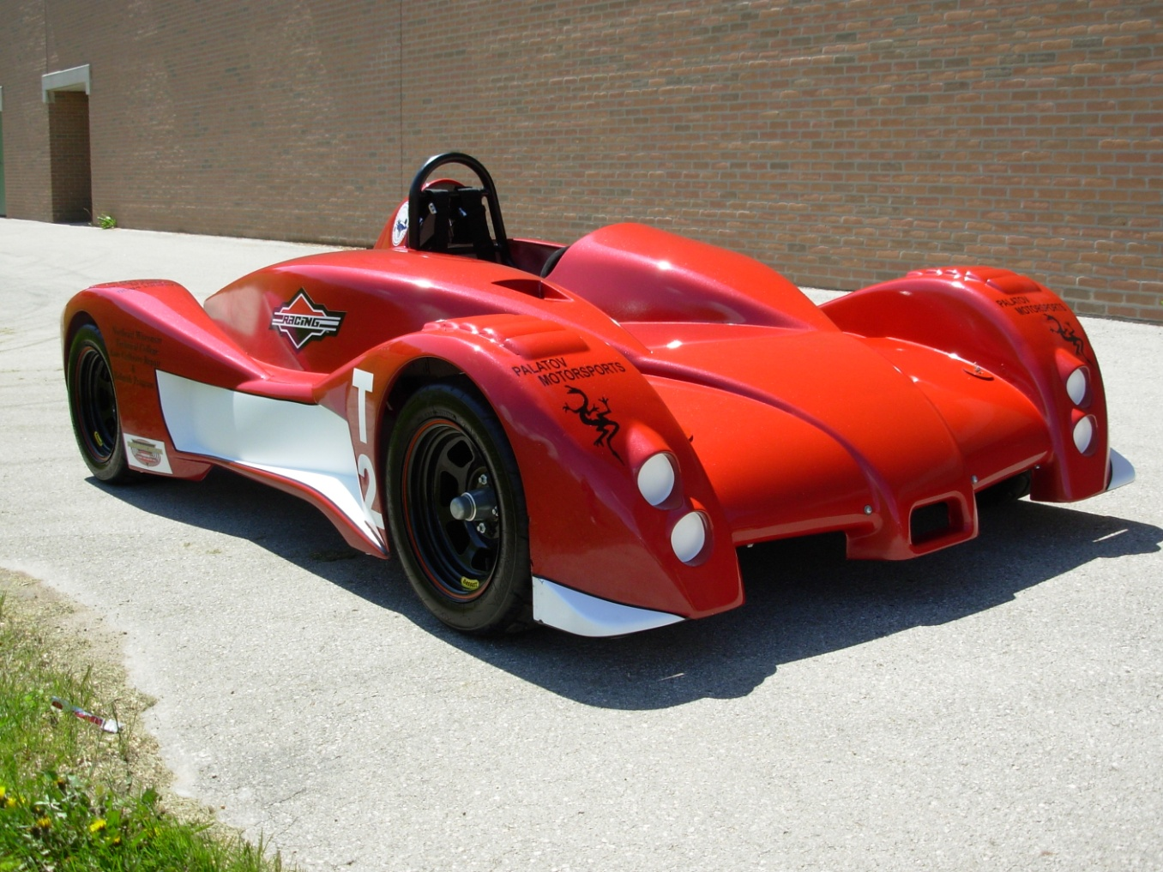

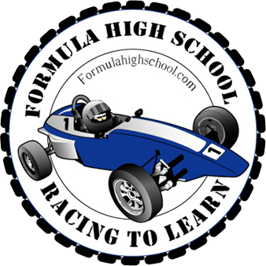

Table of Contents

About Formula High School Page 3

Team Members Page 4

Construction Page 5

Photos from Construction Page 6

Track Day Page 9

Track Day Photos Page 10

Sponsors Page 12
Formula High School

Formula High School was created in 2008 by technology education instructor Mr. Jeremie Meyer to provide a challenging course for high school students to apply engineering principles. This course exposes students to the experience of designing, manufacturing, and testing a working vehicle. Each team is responsible for finding and working with sponsors who paid for the construction of the cars. Although each team made their own modifications to the designs from previous years, the cars appear to look the same. This is due to the safety guidelines put in place and the fiberglass bodies that are used.
Along with the technological skills that are learned, students must also learn how to communicate with other people. Each team has to work through their differences and learn to work together to produce a working vehicle. The Formula High School program also provides a unique experience to work with companies and learn to work in a professional manner. Lessons about the real world are learned through strict deadlines, collaboration with different businesses, and other valuable skills that can be applied in future careers.

Team Members

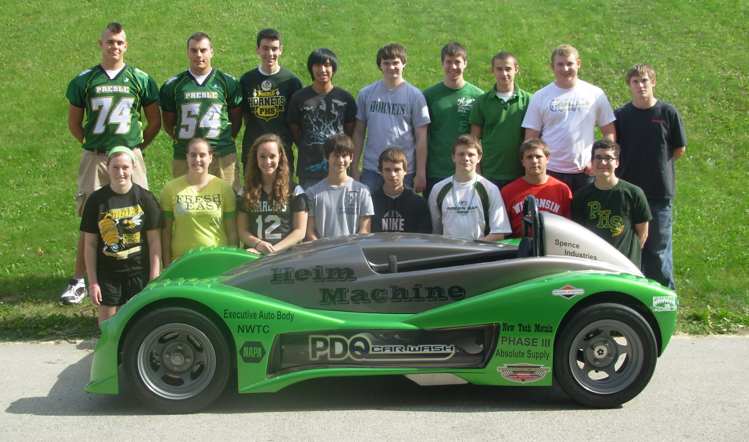

Entire Preble Motorsports Program Above

Team Members:
Donald Clark- Three years CAD
Arianna Grant- Two years CAD and Youth Apprenticeship Program
Kayla Heraly- Three years CAD and Small Engines
Elizabeth Lovering- Three years CAD, RND, and Welding
Jacob Mear- Two years CAD, Welding, Residential and Civil Architecture
Zach Nellis- Welding and Small Engines
Tyler Noel- Three years CAD and Youth Apprenticeship Program
Evan Thielen- Three years CAD, Wood Working, Vehicle Service, Residential and Civil Architecture
Construction

Revisions before Starting
To start things off, the team had to make improvements and revisions on the suspension, transmission, and increased engine size. Our team designed a suspension that is comparable with last year’s design, but requires less machining. The team decided to upgrade to a CVT transmission to increase performance in our vehicle. The three gallon gas tank was converted into a one gallon because the extra fuel was unnecessary during track day and added unnecessary weight.

Starting the Construction Process
After we decided on revisions, calculated how much supply we needed, and ordered our parts; we started the construction process. To create the chassis, one inch square steel tubing was our primary source. After cutting and welding the base chassis together we created the roll-bars. Our roll-bars were bent out of inch and a half tubing then put into place. When the engine arrived, we installed a rev-kit and also added other minor modifications. When the shocks came, we modified them by adding spacers and changing the springs. During our construction process NWTC generously let us use their water-jet as to avoid un-needed machining. NWTC’s, Doug Heim kindly helped create several important parts also throughout the construction process.
The A-arms where completed along with the tie rods. The differential, battery, and engine were all mounted. Next the CVT and the remaining drivetrain were fitted and installed. The steering wheel, rack and pinion were put into place.
One major challenge that our team had to overcome was making the car so that each member was able to drive. With over a foot difference in height between the tallest and shortest members, the cars original design had to be changed. To help accommodate the taller members of the team, the seat pan wasn’t made flat. The seat was dropped down to make more room along with the area right below the pedals. Seat pans were made out of bent aluminum in three different sections. The cockpit area was also enclosed by bent aluminum to create the fire wall. Because the drive shaft was open and a safety hazard, another plate was placed on top. This was held down with bolts so that it could be removed to get to the parts underneath if needed. The pedal assembly was adjustable to move it forward and back depending on the driver. This was done by making a series of holes in the bars that were supporting the assembly. Bolts were then used to hold it down. It was then easily moved by removing the complete assembly and placing the bolts back in.
The exhaust went from the engine through a hole in the back of body and out of the car. It came off from two different areas on the engine and then it was merged into one tube at the end. There was a tube connecting the two separate tubing creating and H in the front of the exhaust. The exhaust was created by bent ¾” round tubing then increasing into a larger sized tube.
After being fitted to the car, the fiberglass body was created at Fiberglass Solutions. The fiberglass body was sanded and excess material was removed. After the body was ready for paint, it was sent off to NWTC to be painted by their auto collision and repair department. The team decided to paint the car red with white racing stripes. With the aid of Myron Mertens, the decals representing our sponsors were added to our body.

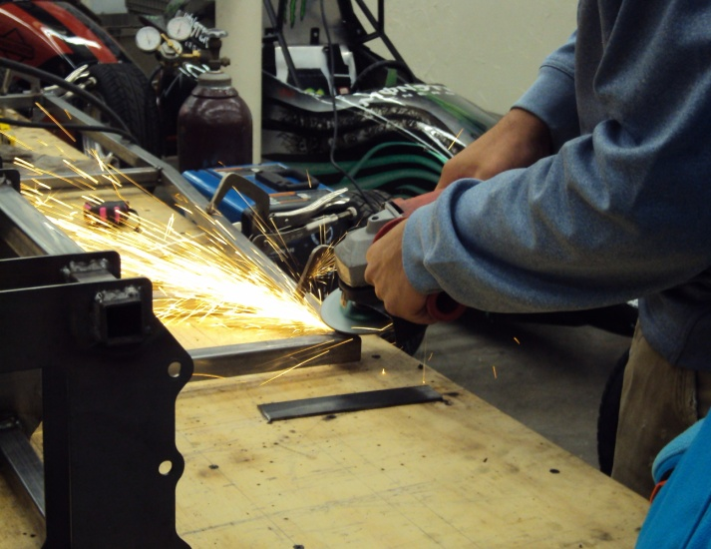
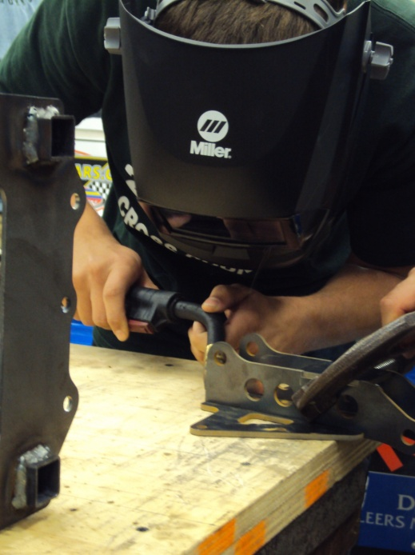
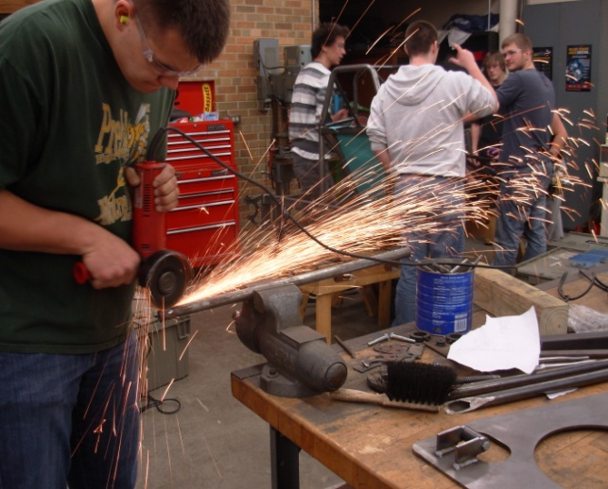
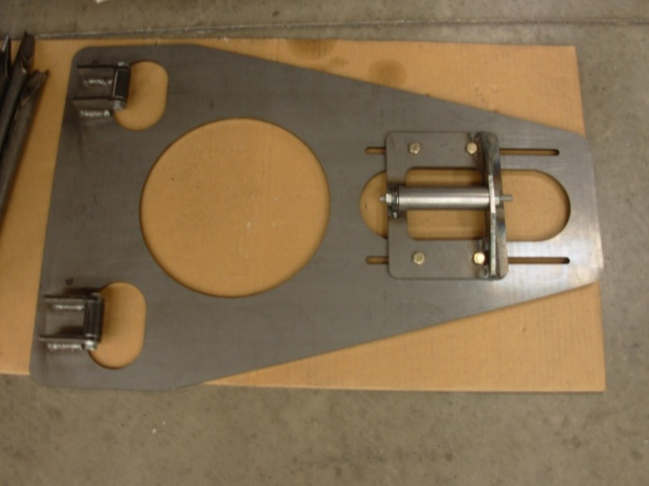
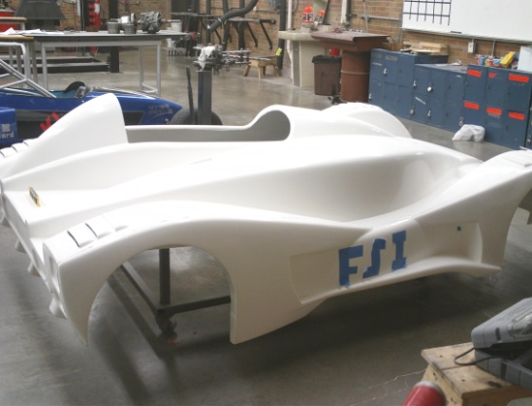
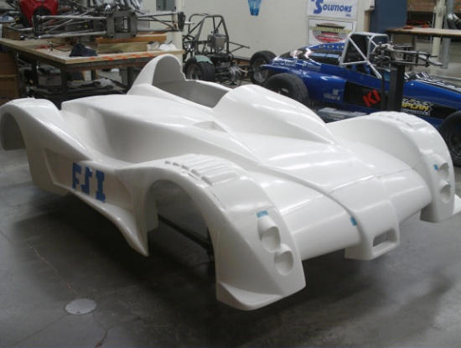
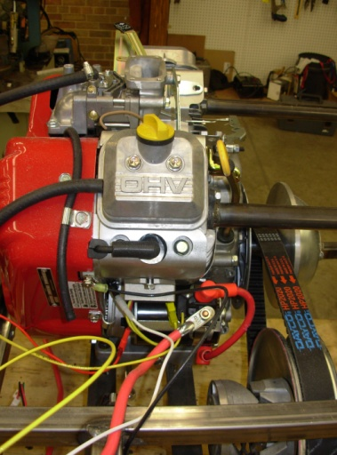
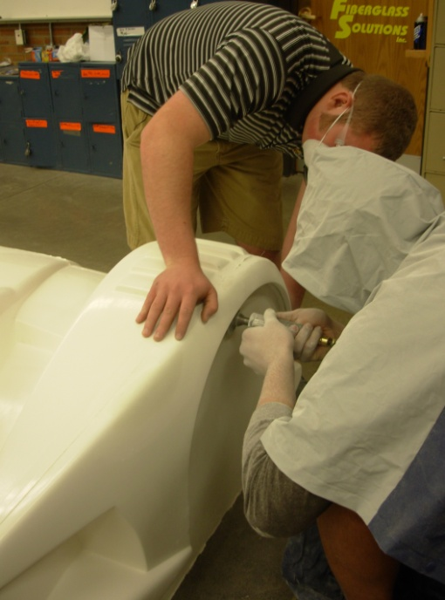
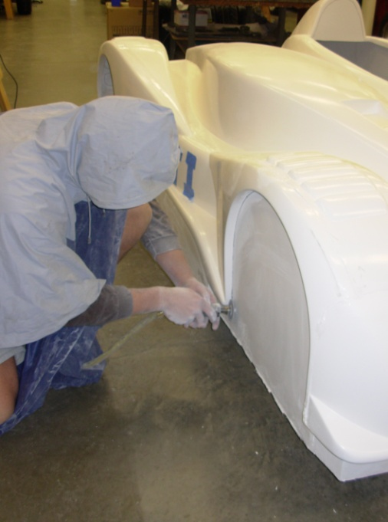
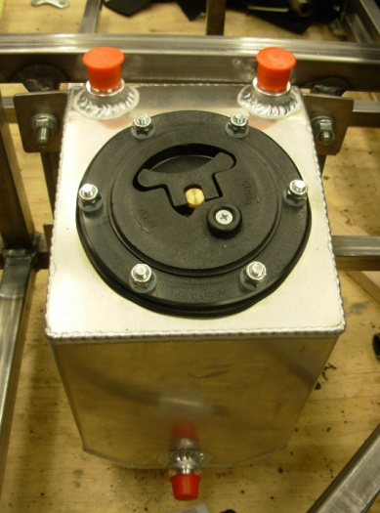
Construction
Team member Zach Nellis welding
Team member Tyler Noel grinding down a weld on the seat support bars
Team member Jake Mears grinding part of the A-arms to the correct angle
A-arm jig created to make the construction of the A-arms easier
Fiberglass body trimmed and ready to be sent to NWTC to be painted
Left: 1 gallon gas tank mounted
Right: The engine mounted with the first parts of the exhaust being added on
Team members Jake Mears and Evan Thielen working on cutting and sanding the fiberglass body to fit the car
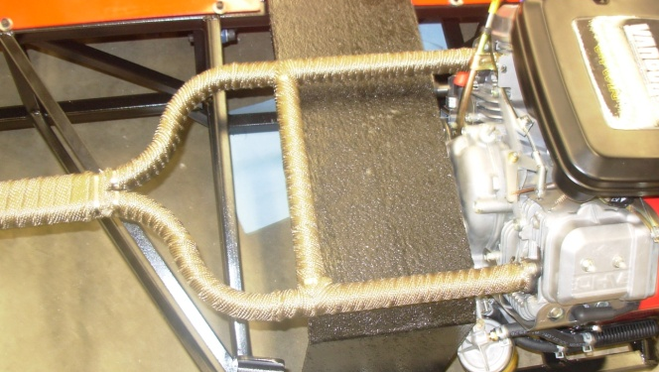
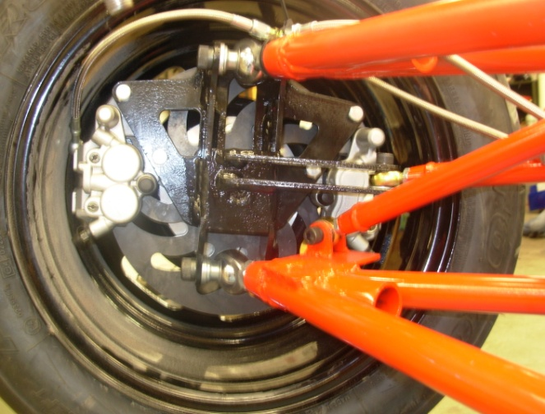
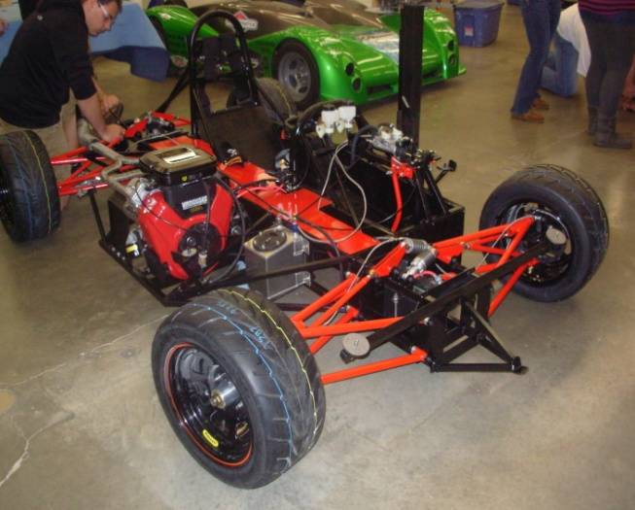
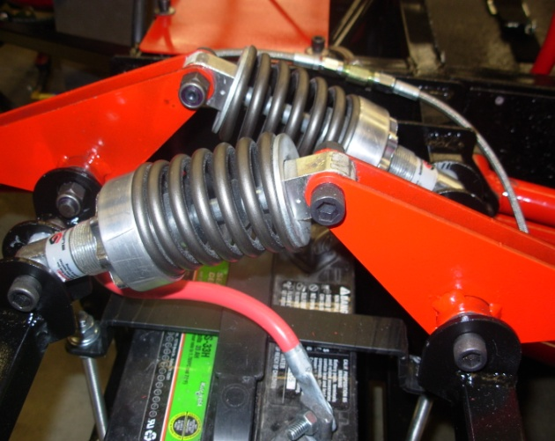
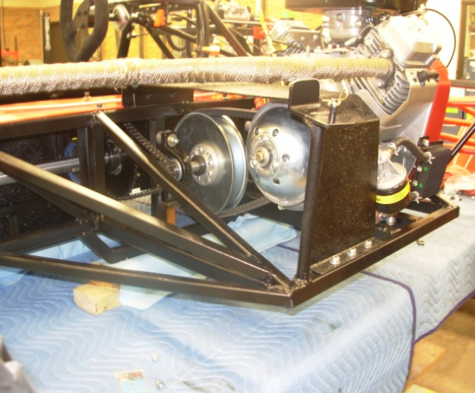
Assembled car with team member Tyler Noel tightening down rear suspension
Front suspension system
CVT clutch mounted, along with engine, exhaust and safety barrier over moving parts
Exhaust system fully mounted on the car
Assembly at front right tire including mounted brake caliper
Track Day

The weekend of April 28-29, Preble High School brought four cars to Blain’s Farm and Fleet Motorplex. The Domini on electric car, the Napa formula car, and the T2 were all built this school year. The T1 was built during the 2010-2011 school year and was brought back to the Motorplex this year. Two vehicles were used to transport the four cars. The two formula cars were brought in a district vehicle while the T1 and T2 were brought in a trailer that was borrowed. Each car was loaded and ratchet strapped down in the days prior to the track weekend by the students and help from Mr. Meyer. Teamwork was displayed through this process, because each car took multiple people to load it. Once we arrived at the track each car was to be unloaded.
This year we were fortunate enough to have no rain and were able to run the cars all day Saturday and Sunday. On Saturday, the courses that they had set up were the oval track and the small road course. The idea of the oval course was for the drivers to get used to driving the cars. This was to help reduce the amounts of crashes on the more challenging courses. The small road course was a step up from the oval. There were more turns along with hills causing the car to both go up an incline and down a decline. On Sunday the large road course was set up. It was the longest of the three courses. With more turns and a bigger challenge, there were more chances to mess up. The T2 spun out once on this course but never came in contact with the barriers. Although the T2 was not compared directly to the other formula cars due to the larger engine and different regulations, in the end the fastest time came in 4th overall.
The track weekend was a chance to prove what each team has learned over the year. If a car broke down, the team was responsible to find the problem and fix it. Thankfully, our team had no real issues with the car, which meant we had more time on the track. We also were able to see who understood how to drive the course the best to achieve the fastest time.
The track weekend is an event that shows off the cars that were built. There were some sponsors that came to the track to see not only their team’s car, but the other cars as well. Mr. Red Lewis, owner of PDQ came to the track. He sponsored the T2 from this year along with the T1 from last year. Our team was proud to show him the car that we built. We were able to show that even though we had a much smaller engine, we were still able to have a car that was just slightly slower than the T1.

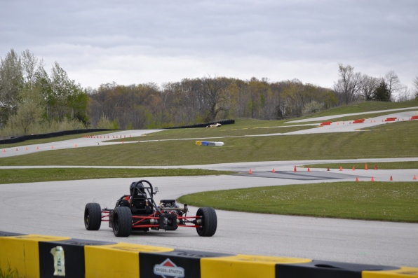
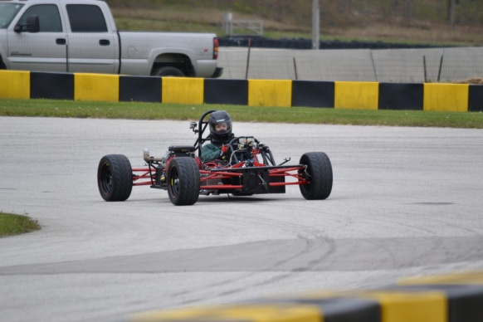
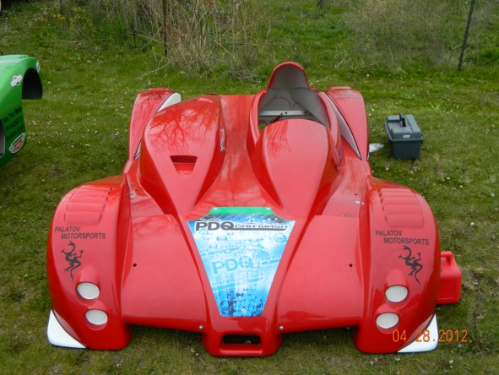
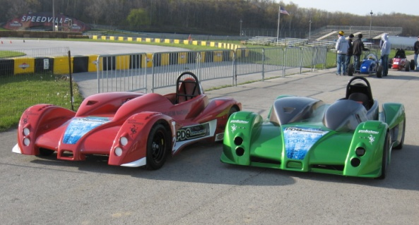
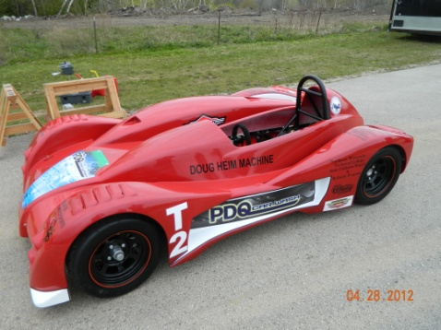
Track Day
Team member Donald Clark on the oval track
Team member Lizzy Lovering on the road course
The T2 body front view with all sponsor decals on
The T2 (red) and the T1 (green) on the track
Team members Tyler Noel and Jake Mears adjusting the pedal placement
The T2 with body on
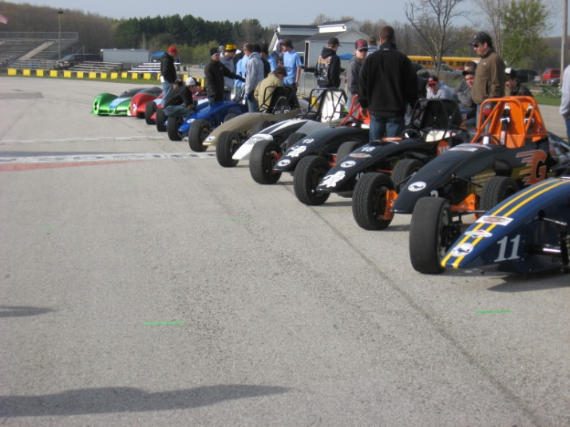
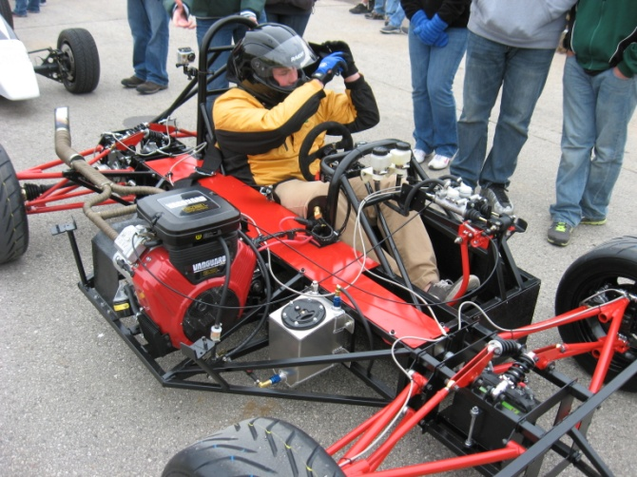
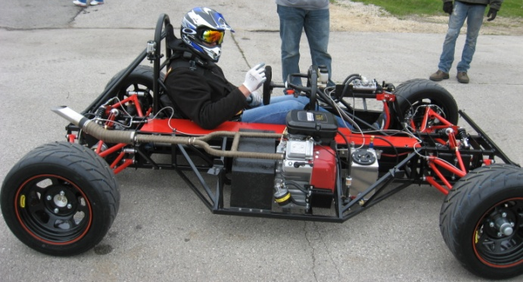
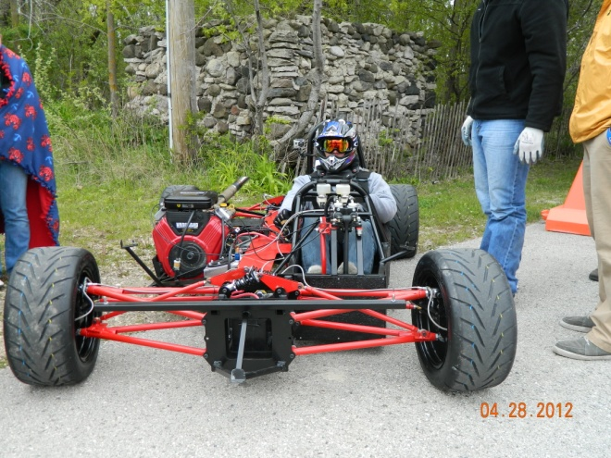
All cars lined up on the road course
Team member Evan Thielen putting on seat belt
Team member Jake Mears in the car ready before going on the track
Team member Tyler Noel ready in the car before going on the track
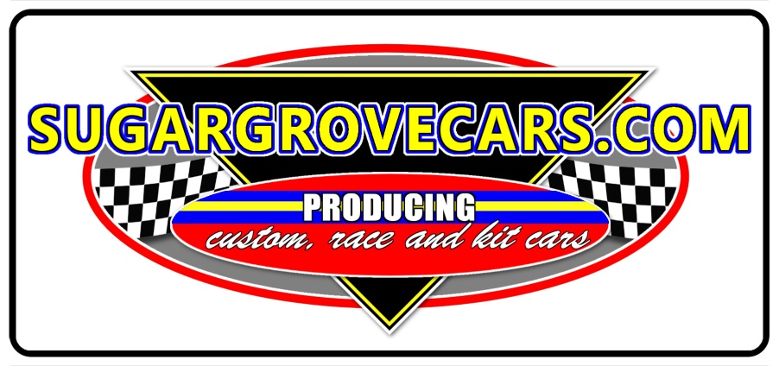
Thank You Sponsors
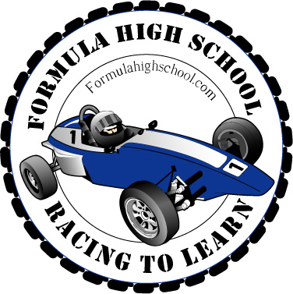
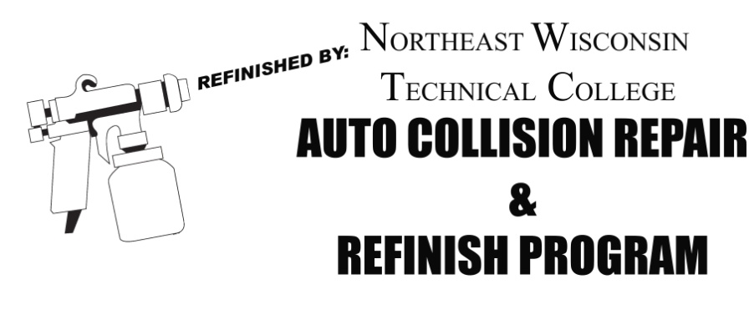
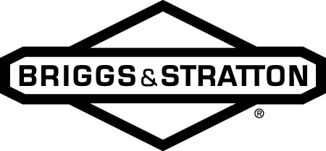
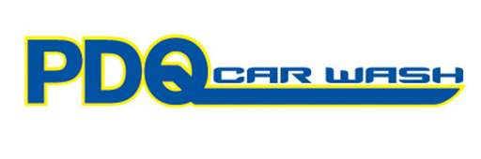
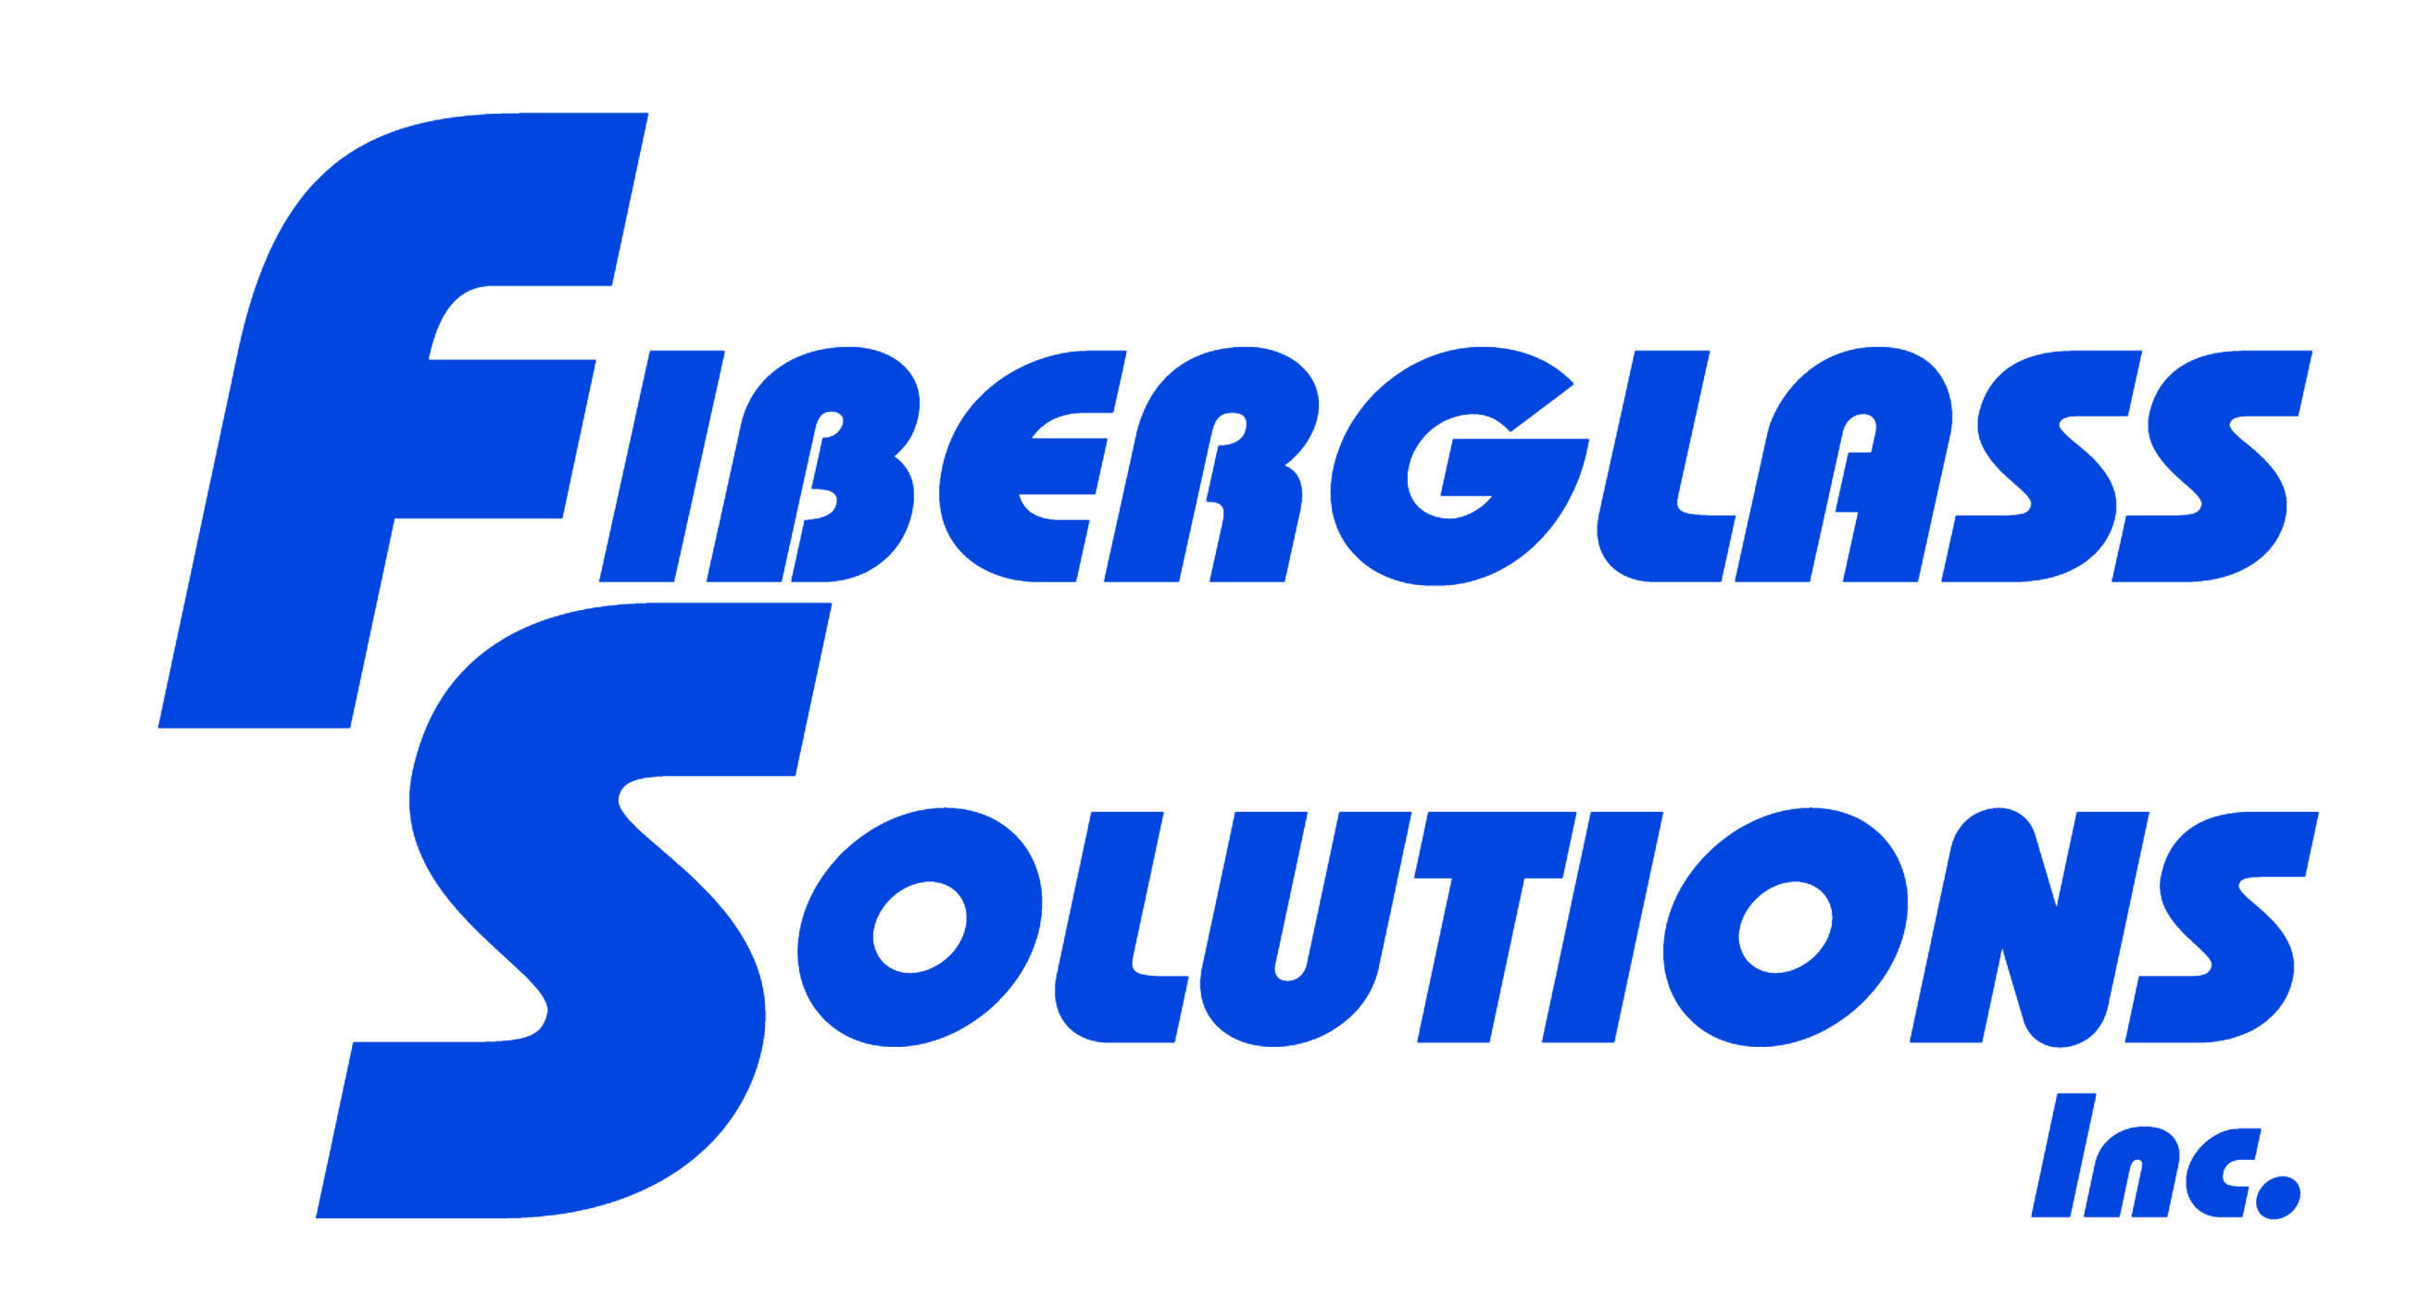
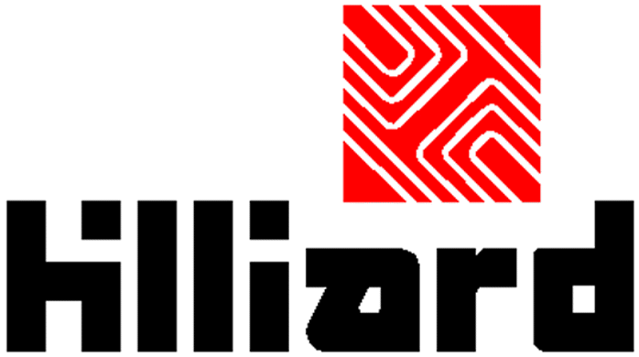
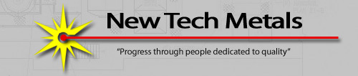
Thank You Sponsors

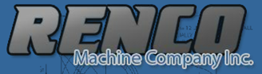
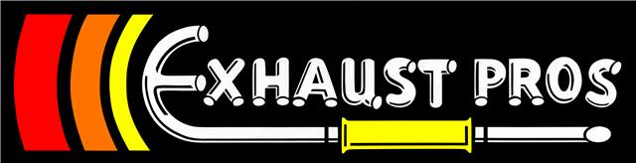

Heim Machine LLC

